**Summit Station Weekly Science Report**

**Reporting Period:**  December 3 – December 9, 2018

**Completed by:** Gus Allen, Troy Nave

**Comments:**

TAWO began experiencing thermoregulation issues at the beginning of the week. Attempts to correct the cooling system are ongoing.   
  
The ICECAPS data transfer failed start on 12-07 due to an issue with the ICECAPS Linux system, which was resolved by a system restart. This resulted in a transfer backlog on 12-07 and 12-08, but the system caught up and is functioning normally at this time.

Wind speeds at Summit ranged from 0.2 m/s, recorded on 2018-12-07, to 8.6 m/s on 2018-12-09. Temperatures ranged from a low of -54.11˚C on 2018-12-04 to a high of -32.01˚C on 2018-12-08. Weekly average wind speed was 4.73 m/s and weekly average temperature was -44.68˚C.

Summit experienced low winds on 2018-12-04 from 00:35 to 02:13, and on 2018-12-06 from 21:13 to 21:32. Summit experienced North winds on 2018-12-03 from 21:25 to 22:06 last week.

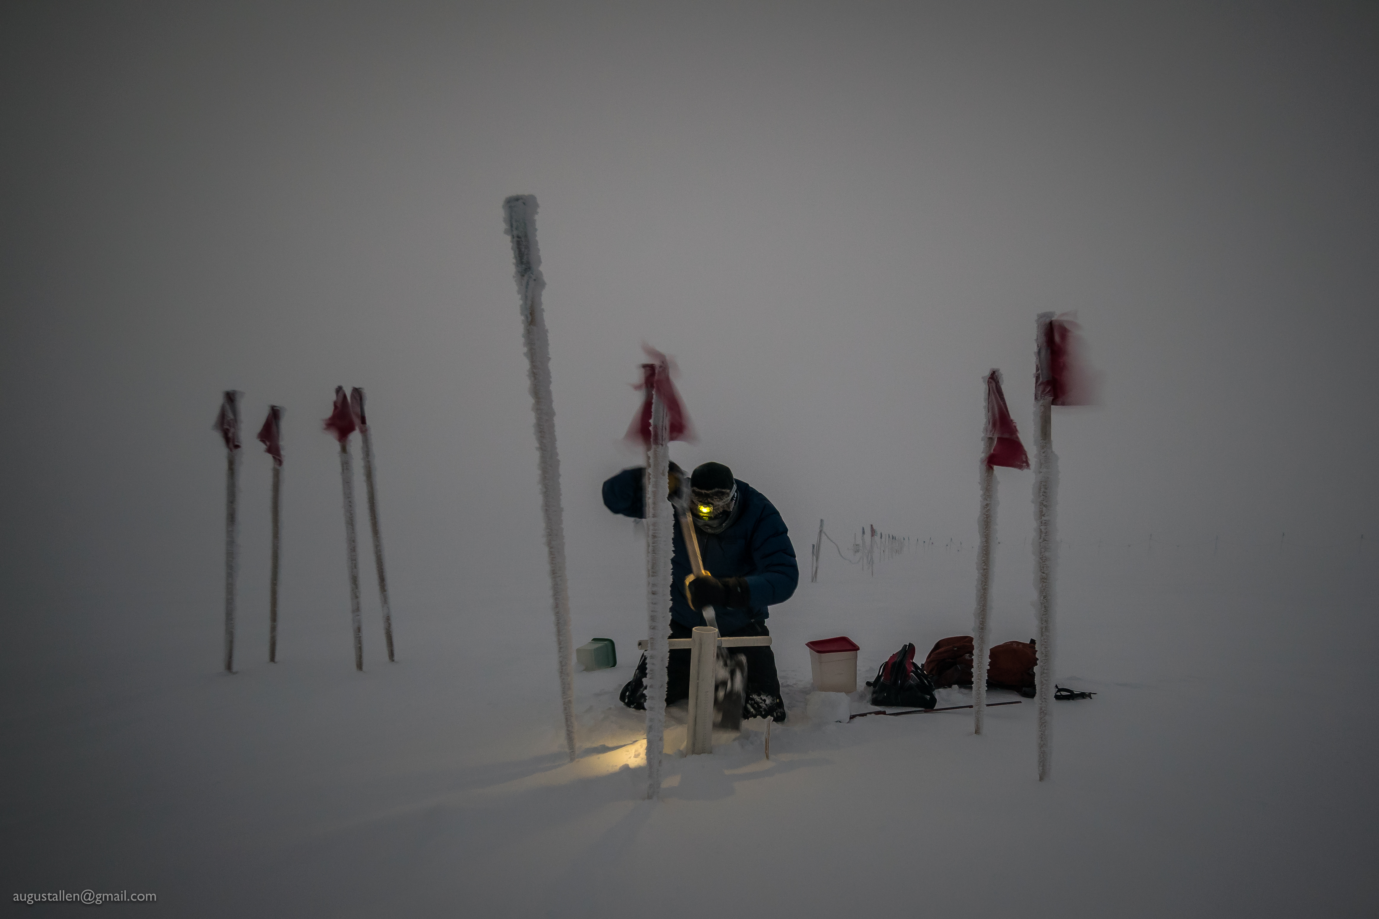

Troy Nave prepares to collect a snow sample for SnowFox in less than ideal conditions

**Please visit the clean air log at ftp://isr.sri.com/pub/summit/ftp/science/clean_air_traffic/**

|  |  |
| --- | --- |
| **Facilities** | **Comment** |
| TAWO | Cooling system malfunction. See above |
| MSF |  |
| Green House |  |
| **Experiment** | **Notes** |
| NOAA CCGG flasks | Comment:  Date performed: 2018-12-13 |
| NOAA HATS flasks | Comment: every other week; performed last week  Date performed: 2018-12-08 |
| NOAA Surface Ozone | Comment: Calibrated on 2018-12-04  % of time operating: 100% |
| NOAA Aethelometer | Comment: Offline since 2018-01-10. Instrument offsite for repair.  % of time operating: 0% |
| NOAA Meteorology | Comment:  % of time operating: 100% |
| NOAA CLAP & Neph | Comment: Nephelometer span check completed 2018-11-28. None last week.  % of time operating: 100% |
| Radionuclide Filter | Comment:  % of time operating: 100% |
| Aerosol DRUM Sampler | Comment:  % of time operating: 100% |
| Bamboo Forest | Comment:  Date performed: 2018-12-07 |
| SnowFox | Comment:  Date performed: 2018-12-05 |
| ICESat Accumulation | Comment:  Date performed: 2018-11-25. None last week. |
| GFZ Potsdam Seismometer | Comment: Seismometer not sensing on GEOFON for 19 hours on 2018-12-04  % of time operating: 89% |
| DTU Magnetometer | Comment:  % of time operating: 100% |
| UNAVCO | Comment: |
| Helmig CUGC | Comment:  % of time operating: 100% |
| Steffen Tower Instruments | Comment:  % of time operating: 100% |
| Steffen Solar Instruments | Comment:  % of time operating: 100% |
| ICECAPS-ACE Total Sky Imager | Comment: Offline for the winter  % of time operating: 0% |
| ICECAPS-ACE Radiosonde | Comment:  Dates performed: Twice daily. |
| ICECAPS-ACE MWR | Comment:  % of time operating: 100% |
| ICECAPS-ACE SODAR | Comment:  % of time operating: 100% |
| ICECAPS-ACE POSS | Comment:  % of time operating: 100% |
| ICECAPS-ACE MASC | Comment: Instrument is offsite for repair and is due to return Summer 2019.  % of time operating: 0% |
| ICECAPS-ACE MMCR | Comment:  % of time operating: 100% |
| ICECAPS-ACE CAPABL | Comment: The CAPABL computer had an error on 12-03, which resolved with a system restart. Instrument is presently operational using laser 2.  % of time operating: ~95% |
| ICECAPS-ACE MPL | Comment:  % of time operating: 100% |
| ICECAPS-ACE Ceilometer | Comment:  % of time operating: 100% |
| ICECAPS-ACE PAERI | Comment:  % of time operating: 100% |
| ICECAPS-ACE IcePIC | Comment: No images captured this week  Date(s) performed: |
| ICECAPS-ACE CLASP | Comment: Instrument removed from MSF for service.  % of time operating: 0% |
| ICECAPS-ACE CPC | Comment: Instrument removed from MSF for service.  % of time operating: 0% |
| ICECAPS-ACE OPC | Comment:  % of time operating: 100% |
|  |  |  |
|  |  |  |